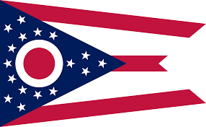
72nd Annual
Tommy Lipps Memorial
AMVETS Mixed State
Bowling Tournament

Two Weekends to choose from: Host Post 464 Address:
Team Event bowled on Saturday @ 11am 5420 Brandt Pike
Doubles/Singles bowled on Sunday @ 10am Huber Heights, OH 45424
1-937-235-2838
Dates:
March 21-22 Bowling Alley:
March 28-29 Marian Lanes
6170 Brandt Pike
Cost: Team (5 member) - $100 Huber Heights, OH 45424
Doubles/Singles - $20 each 1-937-233-2222
Optional HDCP All Events - $5
Optional scratch All Events - $5 Hotel Information:
Call hotel and mention “AMVETS” when booking
Entry deadline is March 1st, 2020, payment for discounted rate.
must accompany entry.
Contract hotels are TBD, check back soon for details.
Must be a current AMVETS member to bowl.
(Open to AMVETS, Sons, Aux, Social/Guest members)
Be sure to pay your 2020 dues or apply today!

